

|  |  |
| --- | --- |
| **Name** | **Komal Fawad**  **Maham Iftikhar** |
| **Subject** | **OOPS** |
| **Assignment#4** | **SNAKES AND LADDERS GAME** |
| **Roll no.** | **SP24-BSE-053(B)**  **SP24-BSE-056(B)** |

**SUBMITTED TO:**

**Sir Muhammad Shahid Bhatti**

|  |
| --- |
| Snakes and Ladders Game Code |

**Import Statements:**

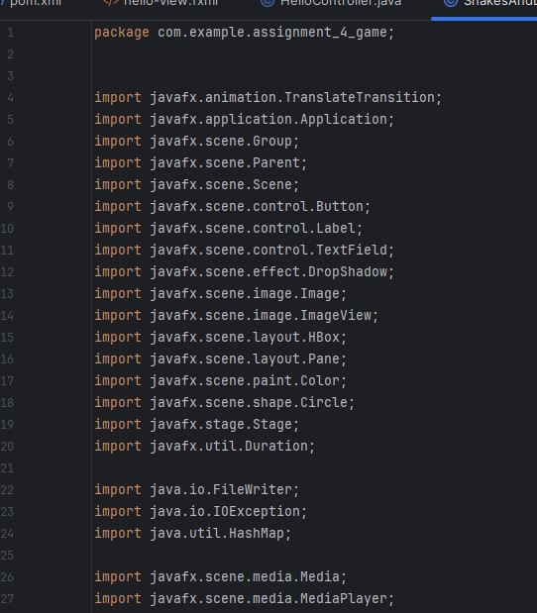

**Snakes and Ladders Attributes:**

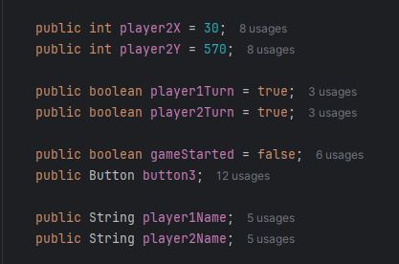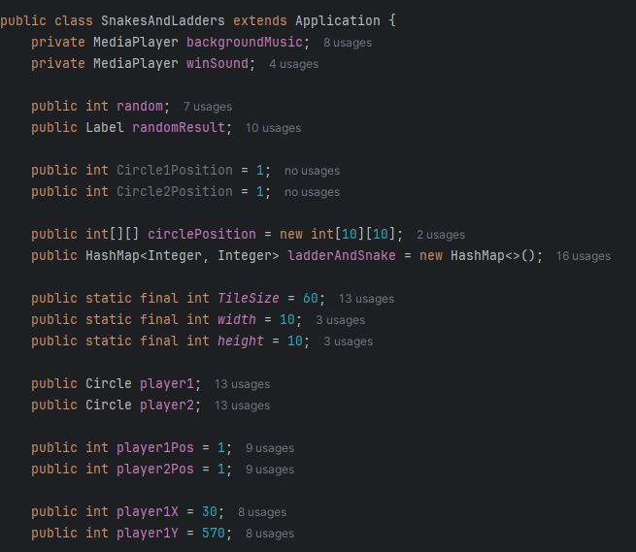

**Snakes and Ladders Methods:**

1. **Login scene Method:**

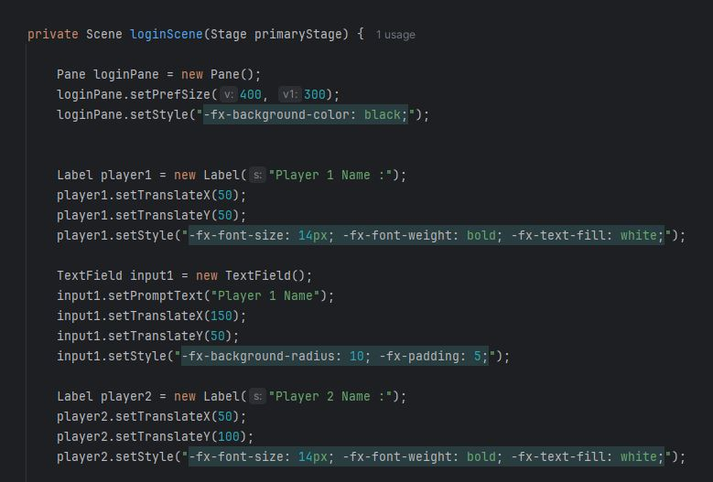

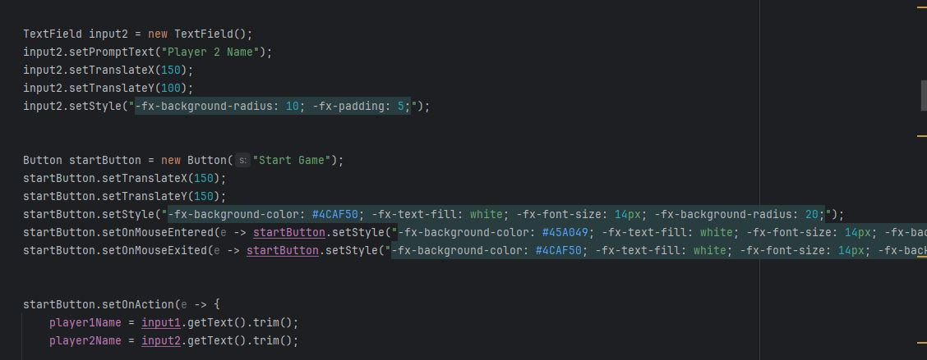

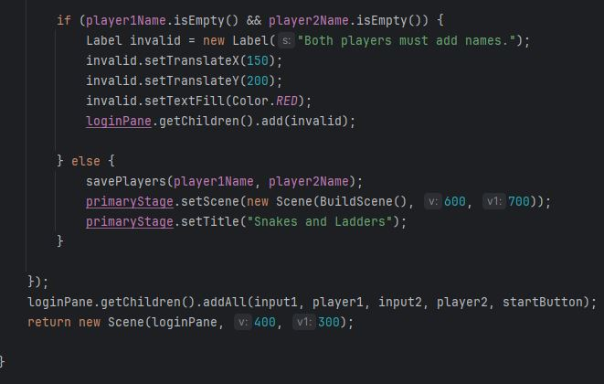

1. Save Players Method:

1. Reset Game Method:

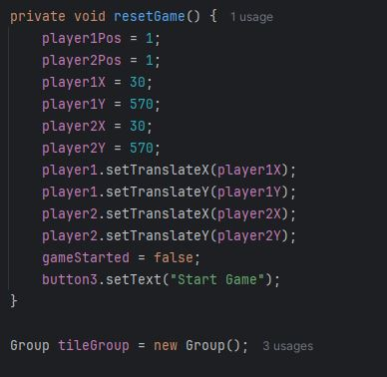

1. Build Scene Method:

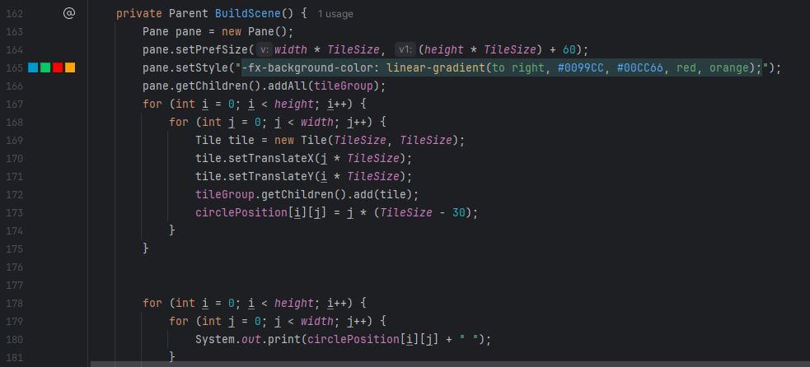

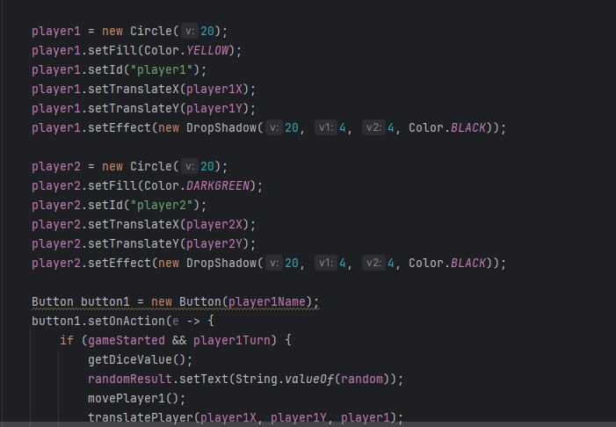

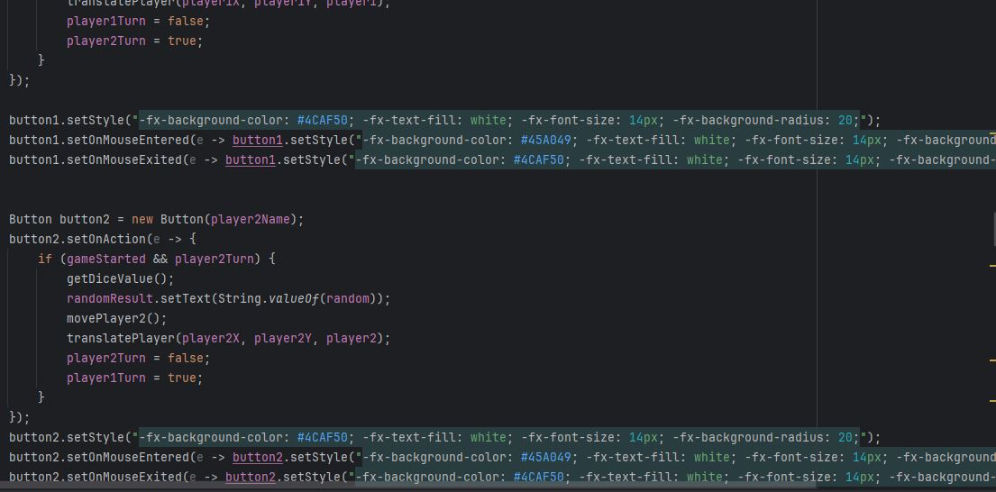

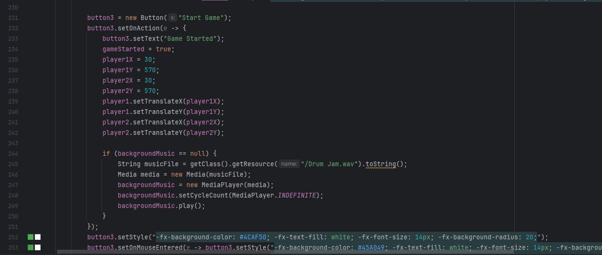

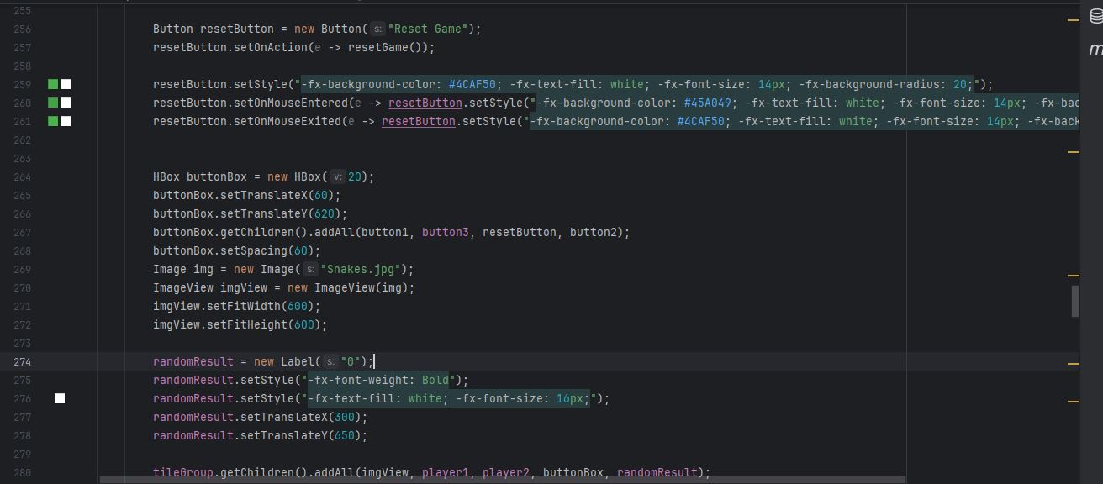

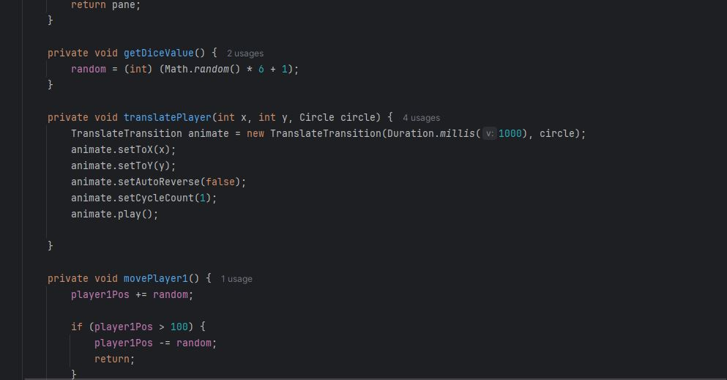

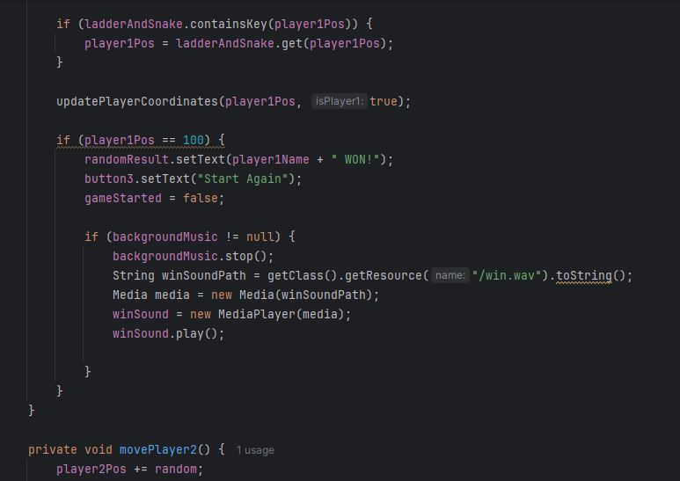

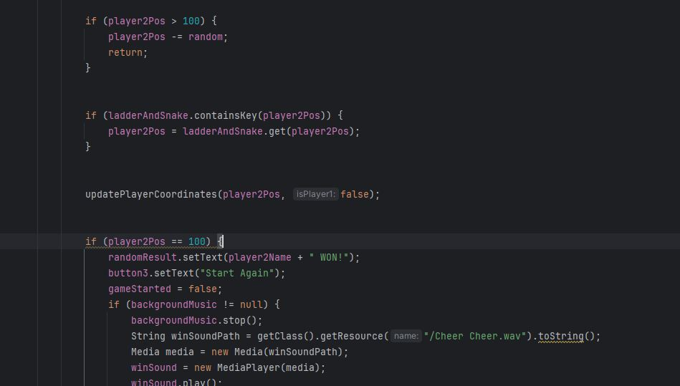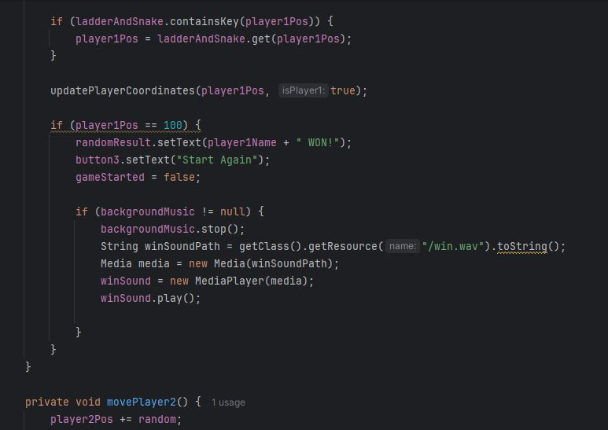

1. A screenshot of a computer program

   Description automatically generated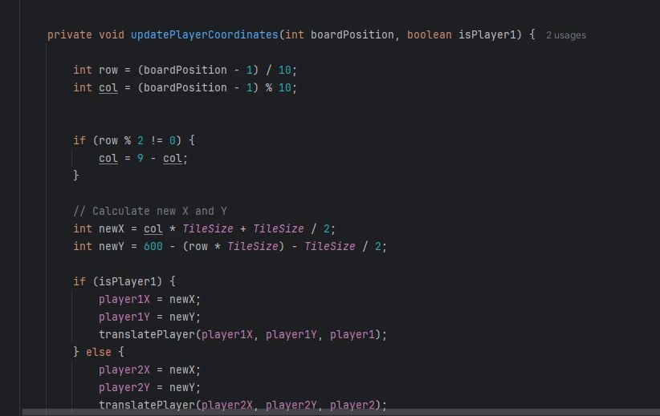Update Players Coordinates Methods:

